SQL and DBMS Wali Shit

SQL became a standard of the American National Standards Institute (ANSI) in 1986, and of the International Organization for Standardization (ISO) in 1987. SQL is case insensitive language.

Fields => column Record => Row of data

DDL[changing db itself] -> CREATE, ALTER, DROP, TRUNCATE, RENAME
DML[changing the table] -> INSERT, UPDATE, DELETE, MERGE
DQL -> SELECT + Loads of shit
DCL[control access and permissions] -> GRANT, REVOKE
TCL[manage transaction] -> COMMIT, ROLLBACK, SAVEPOINT, SET TRANSACTION, BEGIN TRANSACTION

Checkout attlassians entire shit, everything is important…
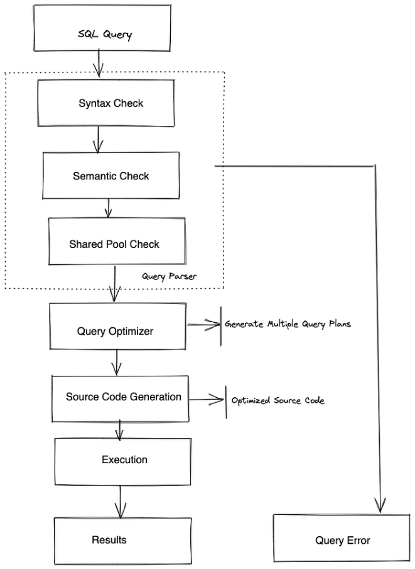
Indexing - > Indexing Essentials in SQL | Atlassian

Shared pool checker – checks if the query has already been parsed or not. Does there already exist a execution plan in and can it be reused.
If already exist then soft execution.Else complete execution.
During initial execution the sql always create a execution plan. Then the execution plan is cached. This makes the SQL language non procedural.

VVIP => How does the query optimisers works?
- Query transformer: The optimizer first analyses the query and may rewrite it into a semantically equivalent but potentially more efficient form (e.g., converting a subquery into a join, or an OR statement into a UNION ALL).
- Estimator: This component estimates the resource cost of each possible plan. It uses database statistics (such as the number of rows in a table, the distribution of values in columns, and the presence of indexes) to calculate measures like cardinality (number of rows returned by an operation) and selectivity (percentage of rows that satisfy a condition).
- Plan Generator: This component explores various combinations of access paths (e.g., full table scan or index scan) and join methods (e.g., nested loops, hash joins, or sort merge) to generate a set of candidate execution plans. It then uses the cost estimates from the estimator to pick the plan with the lowest total cost.
https://medium.com/@shuv.sdr/query-optimization-in-sql-server-fc6f33e0e1d4

VVIP => Optimisation techniques - https://www.dremio.com/blog/sql-query-optimization/

- Understand each line of this very deeply : -> User side query optimisations…
Use indexes wisely
Understand and use execution plans
Avoid using SELECT * in production queries
Limit the use of DISTINCT and ORDER BY
Avoid using CURSOR for set-based operations
Use proper JOINS
Minimize the use of FUNCTIONS in WHERE clauses
Use parameters and stored procedures Be mindful of data types
Consider pagination techniques
Update STATISTICS regularly
Partition large tables
Review and optimize subqueries
Use query hints sparingly
Monitor and analyze performance regularly

SYNTAX :->
- SELECT ______ col1, col2 …..
- DISTINCT -> selects distinct entries from the individual rows of the named column. Deduplication.
- COUNT (cols…) -> counts the number of rows from the col.
- AS -> rename the col for better and easy access.
- TOP _nos_ -> get the top nos from the table.[sql server and ms access]
- TOP _nos_ PERCENT -> fetch the top nos% from the Table.
- LIMIT _nos_ -> Number of rows to return. [my sql]

- AGGREGATE FUNCS: works with SELECT for the SELECT STATEMENT, MIN(_col_), MAX(), COUNT(), SUM(), AVG(), STDDEV() (standard deviation), variance(), median() . Works with the GROUP BY for the categories sorting.

  - OFFSET :- Number of rows to skip. This is 0 based index…
- Two forms of LIMIT in SQL : [imp for DSA]
  - LIMIT _col_to_give _ OFFSET _cols_to_skip_
  - LIMIT OFFSET_val(here arithmetic is valid), _col_to_give

- WHERE: conditions on the queries at end of it all, where ke sath ON lgta hai hamesha.
“=” , > , < , <= , >= ,
BETWEEN _ AND _ -> search between the range.
LIKE -> Search according to the pattern. [case insensitve]
Pattern% -> start with pattern
%pattern -> end with pattern.
%pattern% -> contains the pattern anywhere.
pattern%pattern -> before after pattern.
_ -> allows the single character match.
[chars]% -> any set of chars in the set.
A clause is a component of a SQL statement that tells the database what data to get, from where, how to filter it, how to group it, and how to order it.

Statements :
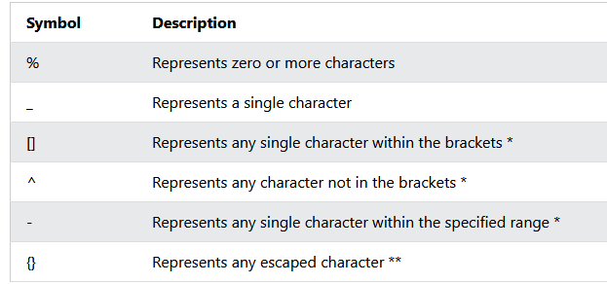
[a-f]% > ex. defines range of a to f.
ILIKE -> [case sencitive] wale ops.
NOT LIKE -> not like us (does not have this pattern)
IN -> Get shit with values.
- ORDER BY _col_names_ ASC/DSC
- AND, OR and NOT
--------------------------------------------------------------------
- INSERT INTO -> Insert new records into the table.
Ex. I I table_name(cols) VALUES(custome_val)
If all cols are not mwntioned the rest of cols will be null.
- NULL vals have no comparison have to use IS NULL and IS NOT NULL with the WHERE.
- UPDATE :-> modify existing record in the DB.
UPDATE table_name
SET column1 = value1, column2 = value2, ...
WHERE condition; [have to use where clause with update or else every record will updated]
- DELETE:- Delete record in the Table
DELETE FROM _table_name_ WHERE _cond_
[have to use where clause with DELETE or else every record will deleted from table]
- DROP TABLE: - Drop individual tables from the database.

JOINS -> operations between Multiple Tables in the DATABASE. Combines rows of multiple tables. Also joins are stackable and multiple tables can be operated at once just stack that bitch.
SELECT ‘table.col_names…’
FROM table_1
JOIN_TYPE table_2 ON _conditon_

col1 INNER JOIN col2 : Select common shit from both table.
col1 LEFT JOIN col2 : Selects common shit and all from left.
col1 RIGHT JOIN col2 : Select common shit and all from right.
col1 FULL JOIN col2 : select all the shit.

Note :
Every JOIN can Have a WHERE, ORDER BY or any other clause to sort further….
Compare rows from current table to same tables other rows.

UNION : combine results of two or more SELECT statements. The UNION operator automatically removes duplicate rows from the result set.
HAVING : The HAVING clause was added to SQL because the WHERE keyword cannot be used with aggregate functions.Having cannot do row level filtering and can only perform the aggregate level filtering. If using without WHERE must aggregate the field/rows using COUNT(), SUM(),AVG() etc.
Filers the group not the individual item.
Syntax order :
SELECT column_name(s)
FROM table_name
WHERE condition # conditions
GROUP BY column_name(s) # bundle together
HAVING condition # use of the conditions on groups
ORDER BY column_name(s) ASC/DSC; # order by ASC or DSC

ANY :-> returns true if any of the subquery val is True.
ALL:-> returns true if all the subquery val is True.
SELECT column_name(s)
FROM table_name
WHERE column_name operator ANY and ALL // if anything in the lower query is true it return true
(SELECT column_name
FROM table_name
WHERE condition);
IFNULL :-> checks if the output of the fetcher is NULL …
In ex below if the statement is null it returns the *….
Select ifnull(
FUNCTION NAME( select distinct salary
From emp
Order by salary desc
Limit 1 offset 1
), //return type…) as sec_name
- LOOK FOR THE leetcode DATABASES question…

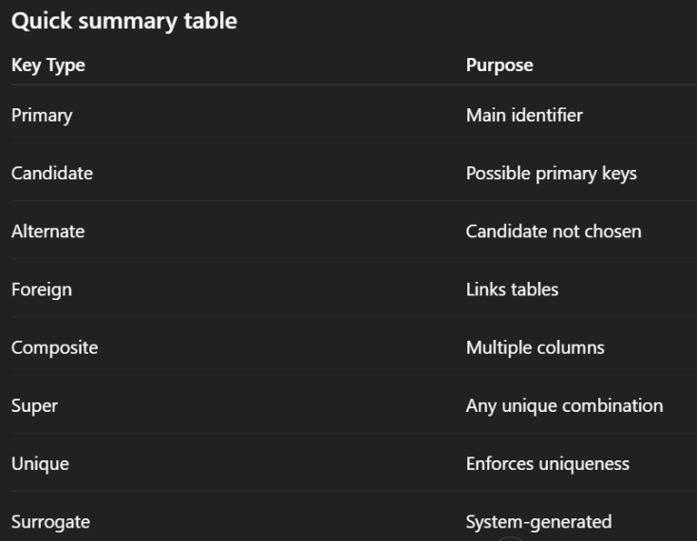
DBMS THEORY
ACID
            - Atomicity
            - Consistency
            - Isolation
            - Durability
BASE -> Basically available, Soft state and eventually consistent.

- Common Problems with Poorly Constructed Joins?
      - Unnecessary cols in the select clause. More cols more time it takes.
      - Joining without proper indexing.

INDEXING
Indexing makes columns faster to query by creating pointers to where data is stored within a database.
Data is stored in the pages of fixed size ie 8kb: Types of pages are data page and index page.
All Data page have
- Header: stores the metadata and the info on the page itself).
- Actual data: rest of the page is filled with the rows and cols.
- Offset: stores the mem address for all the rows for faster access.
All of this data is stored in the pages and is heap structure as the pages are not indexed. At random places.
Search is O(N)
Thus need indexex.

Types of indexes :

- Structure
Two types if structured index are Clustured and non-clustered.

- Clustered:
sort the data according to some metric and then store the data in the b trees. The leafs of the b tree store the data, intermediate rows can store the k-v pair to another page same with the root node. This stores the index for the intermediate nodes too.
- Non clustered indexing:
Do not changes anything in the physical database and index page will store the address of the row itself. And this indexex are also stored in a B tree itself like previous structure.

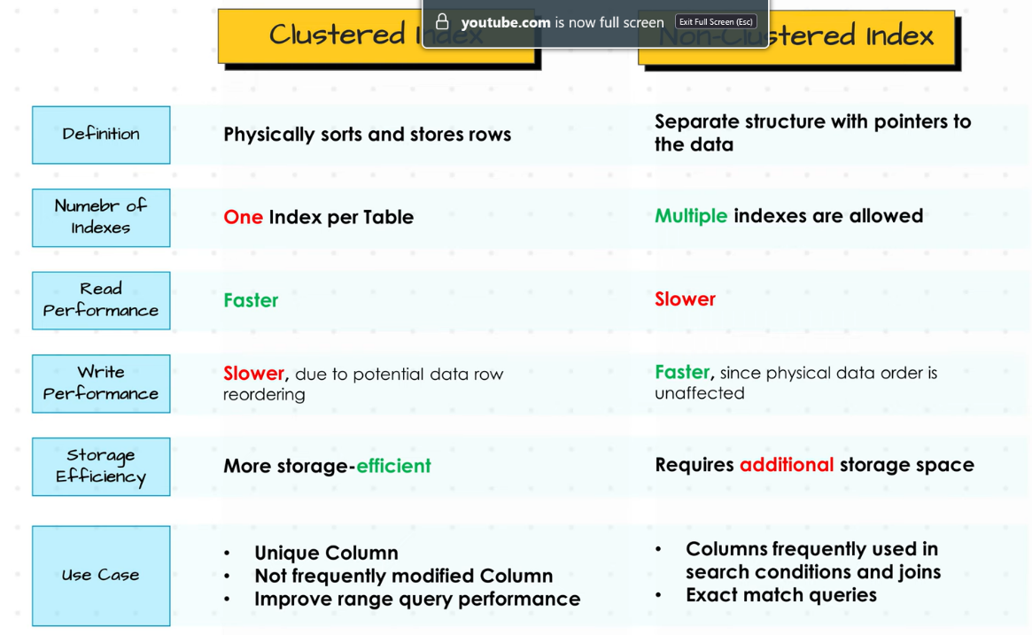
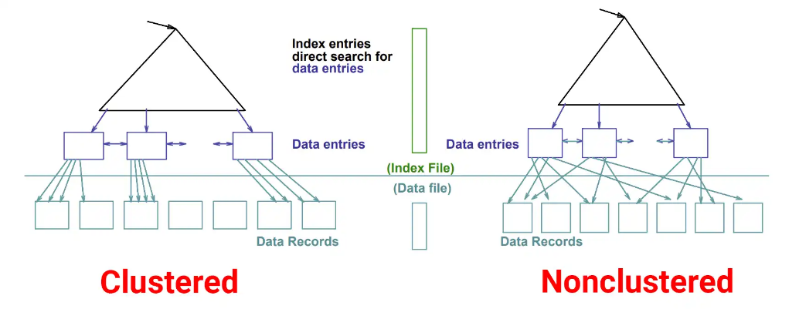
What is better?

Syntax :->
CREATE [clustered|unclusterd] INDEX id_name ON table_name {col_names}
DROP idx_name

Composite indexex : Indexex made by multiple cols are called as composite indexex.
Note: ususllay create indexex for the primary key.

Views in SQL:-> cirtual table build in the result set of an SQL statement. A view contains rows and columns, just like a real table. The fields in a view are fields from one or more real tables in the database.
You can add SQL statements and functions to a view and present the data as if the data were coming from one single table.

VIEW SYNTAX :
CREATE VIEW view_name AS
SELECT column1, column2, ...
FROM table_name
WHERE condition;

SELECT * FROM [view_name];

Views act like a stored function that can be accessed upon later.

Stored procedures:
Store sql query in the DB assign it with a name and use it again and again. An SQL stored procedure can be thought of as a group of SQL instructions that can be easily and repeatedly executed with simple commands. These procedures can also easily take procedures.
Syntax is pretty simple:
CREATE [DEFINER = user]
PROCEDURE [IF NOT EXISTS] <stored_procedure_name> ([<io_parameter>[,...]]) <procedure_body> // simple sql query write krneki
EX:
CREATE PROCEDURE getTop5Users() // creating storable functions that can be called multiple fucking times.
BEGIN

SELECT id, nickname, points
FROM users
ORDER BY points DESC
LIMIT 5
END

Stored procedures can also be nested and expanded upon.
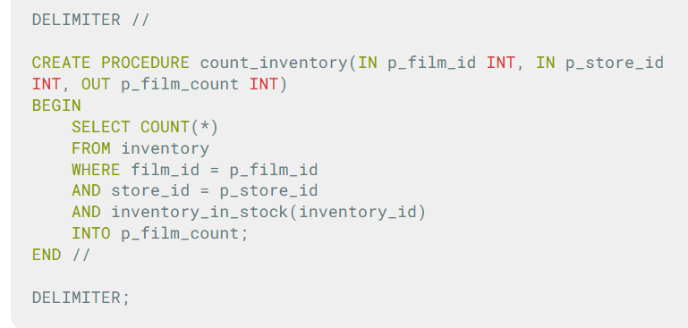

Database principals Basics:
            - Do not duplicate
            - Don’t store calculated data
            - Don’t store atomic parts into the code

            - Follow the normalisation rules:
              - 1nf -> each intersection of rows only has single common col.
              - 2nf -> A table is in 2NF if it is in 1NF and every non-key column fully depends on the whole primary key.
              - 3nf -> A table is in 3NF if it is in 2NF and no non-key column depends on another non-key column.
              - bcnf -> A table is in BCNF if every determinant (column that decides other columns) is a candidate key.
              - 4nf-> A table is in 4NF if it is in BCNF and has no multi-valued dependencies (one key shouldn’t independently determine multiple separate lists).
              - 5nf -> A table is in 5NF if it cannot be split into smaller tables without losing information.

Horizontal scaling (scaling out) means adding more machines or instances to distribute workload. This is common in distributed systems and cloud environments. A load balancer routes requests across multiple servers, improving fault tolerance and availability. For example, an e-commerce site might add more web servers during peak sales to handle traffic spikes without downtime.
Vertical scaling (scaling up) means upgrading the resources (CPU, RAM, storage) of a single machine. This is simpler to implement and works well for monolithic or smaller applications. For example, upgrading a database server from 16 GB to 64 GB RAM to handle more queries. READ About the MVCC.

Understand the semantics of it…
WAL (write ahead log) in sql queries
1. Receive query
2. Parse & optimize
3. Modify data in memory
4. Write change to log buffer (memory)
5. Flush log to disk
6. Commit transaction
7. Later: flush data pages to disk

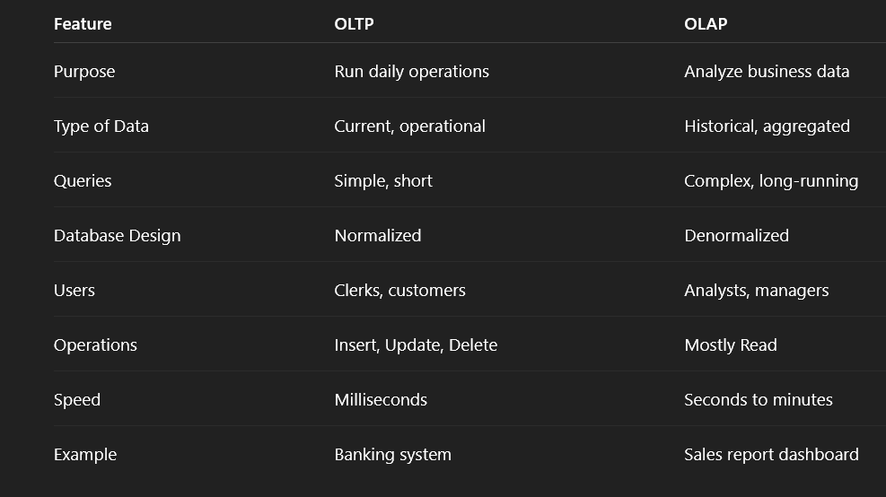
OLTP[online transaction processing] and OLAP[online alalitical processing] :->
SQUENCES
views
triggers
with clause
CTE

Windows :
In SQL, WINDOW refers to a powerful feature for performing calculations across a set of rows that are related to the current row, without collapsing the result set like GROUP BY does.

Query planner and Optimization:

Query optimization is the process of finding the most efficient way to execute a SQL query. Planners job is to find the best way to The optimizer’s job is to choose the fastest plan based on Table size, Indexes, Data distribution, Statistics and Estimated cost. These are all the cost-based estimates and execution strategy and order is based upon the cheapest one in the bunch.

Query plan and Execution strategy:
A query plan is the actual strategy the database decides to use to execute your query. Total cost is calculated by the CPU cost and the IO bound task cost. These statistics are stored in pg_stats I the pg folder. Planner create a tree like structure to execute the needed operations.
Q] EXPLAIN SELECT * FROM users WHERE id = 5;
- Index Scan using users_pkey on users.
- Index Cond: (id = 5);

POSTGRES
PostgreSQL supports object-oriented concepts including table inheritance, custom data types, and complex objects. This means tables can inherit from parent tables, and you can define your own composite types, allowing for more sophisticated data modeling.

Architecture of Postgress :
Process architecture -> create a new process dedicated to that process. Data storage philosophy is very similar to that in the case of SQL pages(8kb), WAL and MVCC.
- Query Processing:
      - Parser and analyser -> syntax converted to parse tree and validate syntax, validate semantics.
      - Query planner the planner generates multiple execution strategies and the optimizer chooses the most efficient one based on cost estimates
      - The executor takes the optimized plan and executes it, fetching data through the buffer manager, which coordinates between memory (shared buffers) and disk storage.

Advance Features of Postgress:
Include multiple indexing strategies beyond B-tree indexes. These include Hash indexes for equality comparisons, GiST (Generalized Search Tree) for geometric and full-text search, GIN (Generalized Inverted Index) for composite values like arrays, BRIN (Block Range Index) for very large tables, and SP-GiST for non-balanced data structures.
Vaccume process reclaims the storage by removing dead tuples and update the statics used by the query planner.
Buffer management - PostgreSQL maintains a shared buffer cache in memory to minimize disk I/O. The effectiveness of this cache significantly impacts performance, along with the operating system's page cache.
Statics are collected and included to further optimize the result of the query planner.
The main advantage of using the MVCC model of concurrency control rather than locking is that in MVCC locks acquired for querying (reading) data do not conflict with locks acquired for writing data, and so reading never blocks writing and writing never blocks reading. PostgreSQL maintains this guarantee even when providing the strictest level of transaction isolation using an innovative Serializable Snapshot Isolation (SSI) level.

Phenomenons blocked by the MVCC transaction control :
- Dirty read -> read operation concurrently to being written by other serializable at the time.
- non repeatable read -> A transaction re-reads data it has previously read and finds that data has been modified by another transaction (that committed since the initial read).
- phantom read -> when a query is executed and fields are written then and if another recently executed transaction is executed at this point, and the satisfying condition does not comply anymore
PostgreSQL: Documentation: 18: 13.2. Transaction Isolation

Q. How MVCC differs from PG and mySQL?
-> While both PostgreSQL and Oracle use MVCC, their implementations differ significantly. PostgreSQL creates new row versions directly in the table, requiring VACUUM to clean up dead tuples. Oracle uses a separate undo tablespace, which can be more efficient but adds complexity.
-> native support for JSON
-> no locks
-> Open source
-> PostgreSQL fits naturally into containerized, microservices, and cloud-native architectures. It's lightweight, starts quickly, and works well in ephemeral infrastructure. Oracle and SQL Server were designed for traditional data centers with permanent infrastructure. They work in the cloud but feel bolted on rather than native.

Algorithms to
expand upon the views -> MERGE algorithm and Temp table

